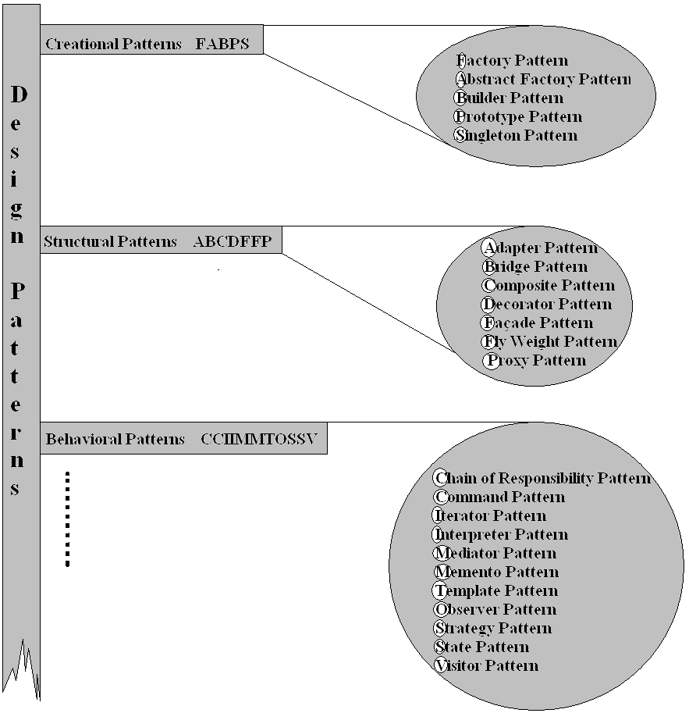
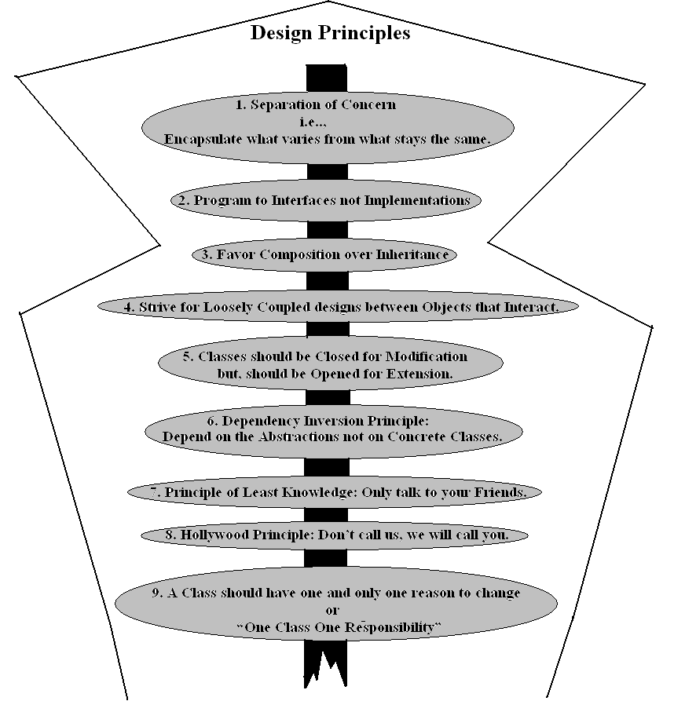

Factory Pattern or Virtual Constructor

Intent:

Define an interface for creating an object, but let subclasses decide which class to
instantiate. Factory Method lets a class defer instantiation to subclasses.

UML:
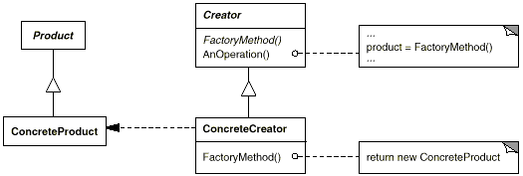

Related Patterns

- Abstract Factory is often implemented with factory methods.
- Factory methods are usually called within Template Methods.
- Prototypes don't require subclassing Creator. However, they often require an Initialize operation on the Product class. Creator uses Initialize to initialize the object. Factory Method doesn't require such an operation.

Examples:

Notes:

Abstract Factory or Kit

Intent:

Provide an interface for creating families of related or dependent objects without
specifying their concrete classes.
Or
Abstract Factory is a factory object that returns one of several factories.

UML:

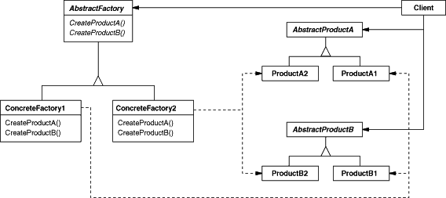

Related Patterns:
- Abstract Factory classes are often implemented with factory methods, but they can also be implemented using Prototype
- A concrete factory is often a singleton
Examples:

Notes:

Builder Pattern

Intent:
Separate the construction of a complex object from its representation so that the same construction process can create different representations.
UML:
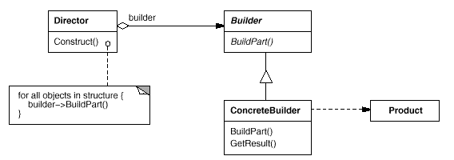
Related Patterns:
- Abstract Factory is similar to Builder in that it too may construct complex objects. The primary difference is that the Builder pattern focuses on constructing a complex object step by step. Abstract Factory's emphasis is on families of product objects (either simple or complex). Builder returns the product as a final step, but as far as the Abstract Factory pattern is concerned, the product gets returned immediately.
- A Composite is what the builder often builds.
Examples:

Notes:

Prototype Pattern

Intent:

Specify the kinds of objects to create using a prototypical instance, and create new
objects by copying this prototype.

UML:
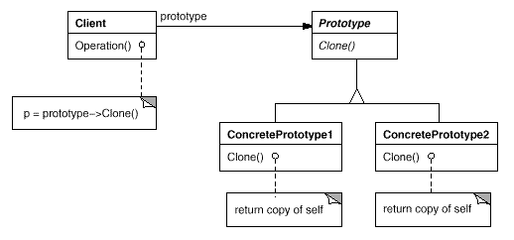

Related Patterns:
- Prototype and Abstract Factory are competing patterns in some ways, as we discuss at the end of this chapter. They can also be used together, however. An Abstract Factory might store a set of prototypes from which to clone and return product objects.
- Designs that make heavy use of the Composite and Decorator patterns often can benefit from Prototype as well

Examples:

Notes:

Singleton Pattern

Intent:

Ensure a class only has one instance, and provide a global point of access to it.

UML:
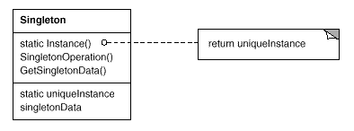

Related Patterns:
- Many patterns can be implemented using the Singleton pattern like Abstract Factory, Builder, and Prototype.
Examples:

Notes:

Adapter or Wrapper Pattern

Intent:

Convert the interface of a class into another interface clients expect. Adapter lets
classes work together that couldn't otherwise because of incompatible interfaces.

UML:
A class adapter uses multiple inheritance to adapt one interface to another
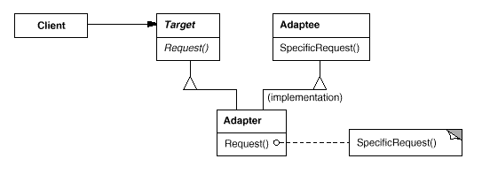
An object adapter relies on object composition:
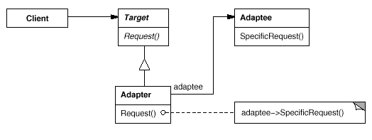
Related Patterns:
- Bridge has a structure similar to an object adapter, but Bridge has a different intent: It is meant to separate an interface from its implementation so that they can be varied easily and independently. An adapter is meant to change the interface of an existing object.
- Decorator enhances another object without changing its interface. A decorator is thus more transparent to the application than an adapter is. As a consequence, Decorator supports recursive composition, which isn't possible with pure adapters.
- Proxy defines a representative or surrogate for another object and does not change its interface.

Examples: Notes:
Bridge or Handle or Body Pattern

Intent:

Decouple an abstraction from its implementation so that the two can vary
independently.

UML:
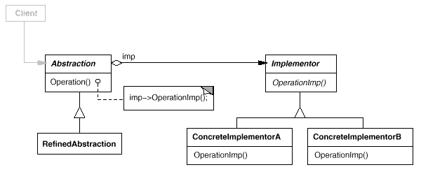

Related Patterns:
- An Abstract Factory can create and configure a particular Bridge.
- The Adapter pattern is geared toward making unrelated classes work together. It is usually applied to systems after they're designed. Bridge, on the other hand, is used up-front in a design to let abstractions and implementations vary independently.
Examples:

Notes:

Composite Pattern

Intent:

Compose objects into tree structures to represent part-whole hierarchies. Composite
lets clients treat individual objects and compositions of objects uniformly.

UML:

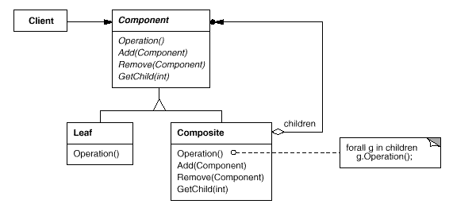
Related Patterns:
- Often the component-parent link is used for a Chain of Responsibility.
- Decorator is often used with Composite. When decorators and composites are used together, they will usually have a common parent class. So decorators will have to support the Component interface with operations like Add, Remove, and Get Child.
- Flyweight lets you share components, but they can no longer refer to their parents.
- Iterator can be used to traverse composites.
- Visitor localizes operations and behavior that would otherwise be distributed across Composite and Leaf classes.
Examples:

Notes:

Decorator or Wrapper Pattern

Intent:

Attach additional responsibilities to an object dynamically. Decorators provide a
flexible alternative to subclassing for extending functionality.

UML:

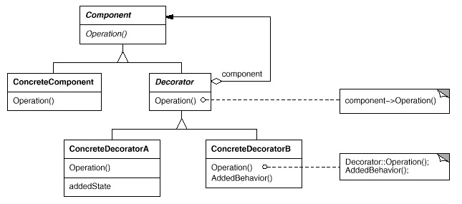

Related Patterns:
- Adapter: A decorator is different from an adapter in that a decorator only changes an object's responsibilities, not its interface; an adapter will give an object a completely new interface.
- Composite: A decorator can be viewed as a degenerate composite with only one component. However, a decorator adds additional responsibilities—it isn't intended for object aggregation.
- Strategy: A decorator lets you change the skin of an object; a strategy lets you change the guts. These are two alternative ways of changing an object.
Examples:

Notes:

Façade Pattern

Intent:

Provide a unified interface to a set of interfaces in a subsystem. Facade defines a
higher-level interface that makes the subsystem easier to use.

UML:

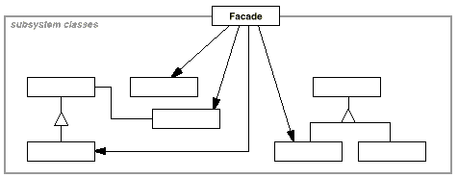

Related Patterns:
- Abstract Factory can be used with Facade to provide an interface for creating subsystem objects in a subsystem-independent way. Abstract Factory can also be used as an alternative to Facade to hide platform-specific classes.
- Mediator is similar to Facade in that it abstracts functionality of existing classes. However, Mediator's purpose is to abstract arbitrary communication between colleague objects, often centralizing functionality that doesn't belong in any one of them. A mediator's colleagues are aware of and communicate with the mediator instead of communicating with each other directly. In contrast, a facade merely abstracts the interface to subsystem objects to make them easier to use; it doesn't define new functionality, and subsystem classes don't know about it.
- Usually only one Facade object is required. Thus Facade objects are often Singletons.
Examples:

Notes:

Fly Weight Pattern

Intent:

Use sharing to support large numbers of fine-grained objects efficiently.

UML:
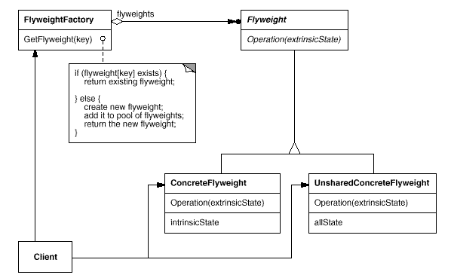

Related Patterns:
- The Flyweight pattern is often combined with the Composite pattern to implement a logically hierarchical structure in terms of a directed-acyclic graph with shared leaf nodes.
- It's often best to implement State and Strategy objects as flyweights.
Examples:

Notes:

Proxy or Surrogate Pattern

Intent:

Provide a surrogate or placeholder for another object to control access to it.

UML:
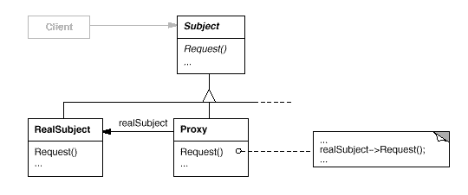
Here's a possible object diagram of a proxy structure at run-time:
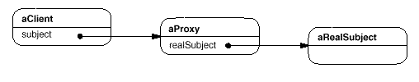
Related Patterns:
- Adapter: An adapter provides a different interface to the object it adapts. In contrast, a proxy provides the same interface as its subject. However, a proxy used for access protection might refuse to perform an operation that the subject will perform, so its interface may be effectively a subset of the subject's.
- Decorator: Although decorators can have similar implementations as proxies, decorators have a different purpose. A decorator adds one or more responsibilities to an object, whereas a proxy controls access to an object.
- Proxies vary in the degree to which they are implemented like a decorator. A protection proxy might be implemented exactly like a decorator. On the other hand, a remote proxy will not contain a direct reference to its real subject but only an indirect reference, such as "host ID and local address on host." A virtual proxy will start off with an indirect reference such as a file name but will eventually obtain and use a direct reference.
Examples: Notes:

Chain of Responsibility Pattern

Intent:

Avoid coupling the sender of a request to its receiver by giving more than one object a
chance to handle the request. Chain the receiving objects and pass the request along
the chain until an object handles it.

UML:
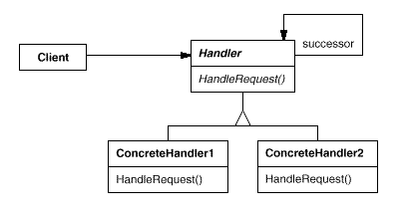
A typical object structure might look like this:
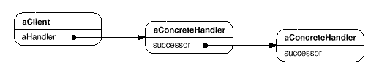
Related Patterns:

- Chain of Responsibility is often applied in conjunction with Composite. There, a component's parent can act as its successor.

Examples:

Notes:

Command or Action or Transaction Pattern

Intent:

Encapsulate a request as an object, thereby letting you parameterize clients with
different requests, queue or log requests, and support undoable operations.

UML:
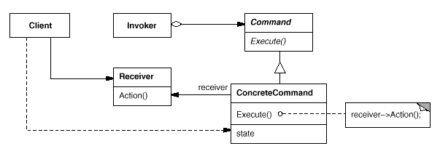
Related Patterns:
- A Composite can be used to implement MacroCommands.
- A Memento can keep state the command requires to undo its effect.
- A command that must be copied before being placed on the history list acts as a Prototype.
Examples:

Notes:

Iterator or Cursor Pattern

Intent:

Provide a way to access the elements of an aggregate object sequentially without
exposing its underlying representation.

UML:
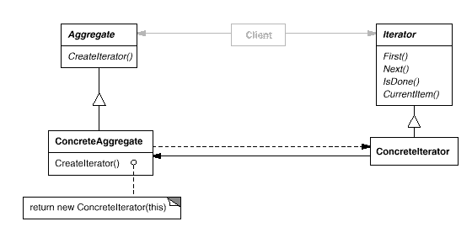

Related Patterns:
- Composite: Iterators are often applied to recursive structures such as Composites.
- Factory Method: Polymorphic iterators rely on factory methods to instantiate the appropriate Iterator subclass.
- Memento is often used in conjunction with the Iterator pattern. An iterator can use a memento to capture the state of an iteration. The iterator stores the memento internally.
Examples:

Notes:

Interpreter Pattern

Intent:

Given a language, define a representation for its grammar along with an interpreter
that uses the representation to interpret sentences in the language.

UML:
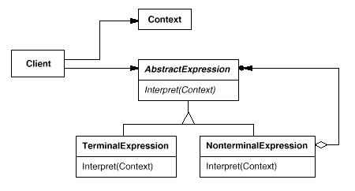

Related Patterns:
- Composite: The abstract syntax tree is an instance of the Composite pattern.
- Flyweight shows how to share terminal symbols within the abstract syntax tree.
- Iterator: The interpreter can use an Iterator to traverse the structure.
- Visitor can be used to maintain the behavior in each node in the abstract syntax tree in one class.
Examples:

Notes:

Mediator Pattern

Intent:

Define an object that encapsulates how a set of objects interact. Mediator promotes
loose coupling by keeping objects from referring to each other explicitly, and it lets
you vary their interaction independently.

UML:
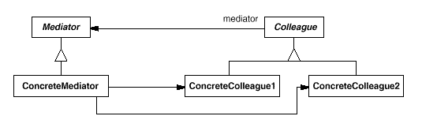
A typical object structure might look like this:
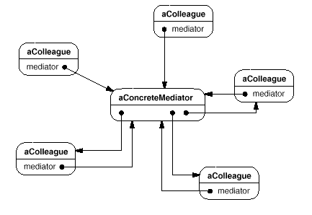
Related Patterns:
- Facade differs from Mediator in that it abstracts a subsystem of objects to provide a more convenient interface. Its protocol is unidirectional; that is, Facade objects make requests of the subsystem classes but not vice versa. In contrast, Mediator enables cooperative behavior that colleague objects don't or can't provide, and the protocol is multidirectional.
- Colleagues can communicate with the mediator using the Observer pattern.
Examples:

Notes:
Memento or Token Pattern

Intent:

Without violating encapsulation, capture and externalize an object's internal state so
that the object can be restored to this state later.

UML:
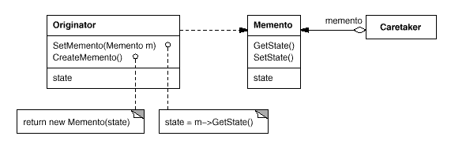
Related Patterns:
- Command: Commands can use mementos to maintain state for undoable operations.
- Iterator: Mementos can be used for iteration as described earlier.
Examples:

Notes:

Template Method Pattern

Intent:

Define the skeleton of an algorithm in an operation, deferring some steps to
subclasses. Template Method lets subclasses redefine certain steps of an algorithm
without changing the algorithm's structure.

UML:
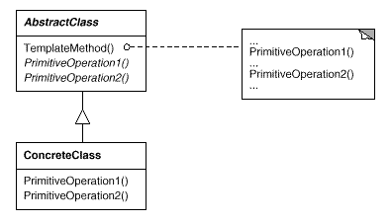

Related Patterns:
- Factory Methods are often called by template methods. In the Motivation example, the factory method DoCreateDocument is called by the template method OpenDocument.
- Strategy: Template methods use inheritance to vary part of an algorithm. Strategies use delegation to vary the entire algorithm.
Examples:

Notes:

Observer or Dependents or Publish-Subscribe Pattern

Intent:

Define a one-to-many dependency between objects so that when one object changes
state, all its dependents are notified and updated automatically.

UML:
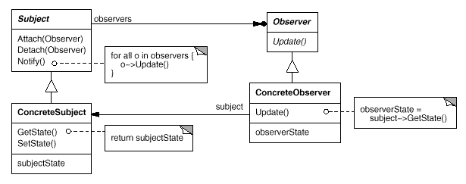

Related Patterns:
- Mediator: By encapsulating complex update semantics, the ChangeManager acts as mediator between subjects and observers.
- Singleton: The ChangeManager may use the Singleton pattern to make it unique and globally accessible.
Examples:

Notes:

Strategy or Policy Pattern

Intent:

Define a family of algorithms, encapsulate each one, and make them interchangeable.
Strategy lets the algorithm vary independently from clients that use it.

UML:
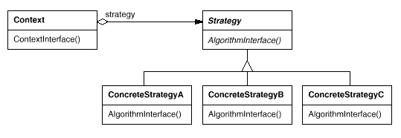

Related Patterns:
- Flyweight: Strategy objects often make good flyweights.

Examples:

Notes:

State or Objects for States Pattern

Intent:

Allow an object to alter its behavior when its internal state changes. The object will
appear to change its class.

UML:
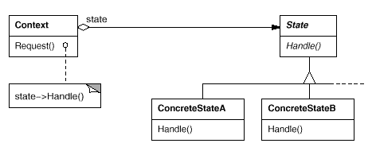

Related Patterns:
- The Flyweight pattern explains when and how State objects can be shared.
- State objects are often Singletons.
Examples:

Notes:

Visitor Pattern

Intent:

Represent an operation to be performed on the elements of an object structure. Visitor
lets you define a new operation without changing the classes of the elements on which
it operates.

UML:

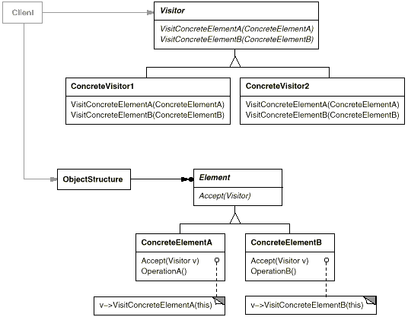

Related Patterns:
- Composite: Visitors can be used to apply an operation over an object structure defined by the Composite pattern.
- Interpreter: Visitor may be applied to do the interpretation.
Examples:

Notes:

